附件2
专家简介
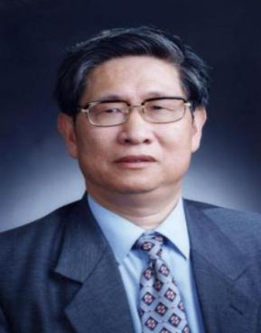
刘昌孝院士
著名药理学家和药代动力学家，中国工程院院士、博士生导师。现任天津中医药大学中药学院院长，天津药物研究院名誉院长和学术委员会主任、释药技术与药代动力学国家重点实验室主任，国家纳米研究院纳米生物医药评价研究中心主任，中国-东盟传统药物研究国际合作联合实验室主任。享受国务院特殊津贴专家、全国劳动模范、全国优秀科技工作者，荣获香港紫荆花医学成就奖、国际药代学会（ISSX）特别贡献奖以及中国药学会特殊贡献奖。刘昌孝院士是我国药代动力学的学科开拓者，于1968年建立第一个药代实验室，1975年率先将该学科用于新药评价，1980年出版国内第一本药代动力学专著，1995年建立国内第一个部级药代动力学重点实验室，2003年建立国内第一个省部共建国家药代动力学重点实验室。在已鉴定的药代程序中提出模型优化和数据批处理方案，使之应用遍及国内数百单位，被国内外8000多篇研究论文应用和引用。刘昌孝院士长期致力于新药研究，承担50多项国家和部省重大研究项目，带领完成近150个新药的药代动力学研究，获得国际、国家和省部级科技成果奖励40余项，发表论文400多篇，出版中英文学术专著20余本。刘昌孝院士为我国药动学、药物评价学、中药现代化发展奠定了基础，做出了卓越贡献。
Academician Liu Changxiao
Famous pharmacologist and pharmacokineticist, academician of Chinese Academy of Engineering, doctoral tutor. Currently the president of the College of traditional Chinese medicine of Tianjin University of traditional Chinese medicine, honorary dean of Tianjin Research Institute of Medicine and director of State Key Laboratory of Drug Delivery Technology and Pharmacokinetics. Director of evaluation and research center of Nanobiomedicine, National Nanotechnology Research Institute, director of China-ASEAN Joint Laboratory for international cooperation in traditional medicine research. He is an expert with special allowance from the State Council, a national model worker, and a national outstanding scientific and technological researcher. He has been awarded the Hong Kong Bauhinia medical achievement award, the ISSX special contribution award and the Chinese Pharmaceutical Association Special Contribution Award. Academician Liu established the first pharmaceutical laboratory in 1968 and firstly applied this discipline on new drug appraisal in 1975. In the year of 1980, he published the first monograph of pharmacokinetics. In 2003, he established the first National Key Laboratory of pharmacokinetics. Furthermore, Academician Liu has proposed the use of optimization model and batch data processing in the authentication procedures of pharmacokinetic, which have been applied across more than hundreds research institutes in China and cited in more than 8000 local and international journals. Academician Liu has long term been committed in new drug research, assumed up to 50 national and provincial science and technology projects and 150 innovative drug pharmacokinetic researches. Moreover, Academician Liu has won 40 international, national and provincial achievement awards. Besides, Academician Liu has published more than 400 journals and 20 Chinese-English monographs. Academician Liu Changxiao has laid a foundation for the development of pharmacokinetics, pharmacoevaluation and modernization of traditional Chinese medicine in China, and has made outstanding contributions.
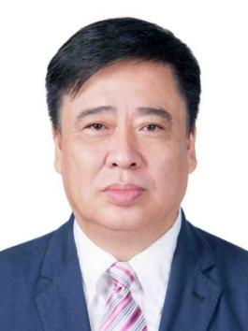
王喜军 教授

黑龙江中医药大学副校长，国家二级教授，博士生导师，国家重点学科中药学A+学科带头人，享受国务院特殊津贴专家，中央直接联系专家，国务院学科评议组成员。兼任教育部经典名方有效性评价工程研究中心主任，国家中医方证代谢组学研究中心主任；俄罗斯阿穆尔国立医学院、澳门科技大学、香港浸会大学兼职教授。任世界中医药学会联合会中药鉴定专业委员会会长，中日医学交流协会汉方药物研究会会长，世界中医药学会联合会中药药理专业委员会副会长，第十届国家药典委员会委员。长期从事中药药效物质基础及作用机制研究，首创中药血清药物化学研究方法及中医方证代谢组学技术，共建中药有效性研究技术创新体系。以第一完成人获国家技术发明二等奖1项，获国家科技进步二等奖1项；获省部级科学技术一等奖7项；获国际发明专利4件，国家发明专利22件，软件著作权8个；出版专著17部，发表论文370余篇，其中SCI论文238篇，被Lancet等总引用17000次；获岐黄学者、全国中青年医学科技之星、全国优秀教师、全国优秀科技工作者、吴阶平医药创新奖及吴阶平保罗杨森医学药学奖等国家级荣誉称号。

Prof. Wang Xijun
Vice President of Heilongjiang University of Chinese Medicine, national second grade professor, doctoral supervisor, national key discipline Chinese pharmacy A+ subject leader, expert enjoying special allowance from the State Council, expert directly contacted by the central government, member of the subject review group of the State Council.He is also the director of the Engineering Research Center for the Effectiveness Evaluation of Classical Prescriptions of the Ministry of Education, and the director of the National Research Center for Metabolomics of Traditional Chinese Medicine;He is the chairman of the Chinese Medicine Appraisal Committee of the World Federation of Chinese Medicine Societies, the chairman of the Kampo Medicine Research Association of the China-Japan Medical Exchange Association, the vice chairman of the Chinese Medicine Pharmacology Committee of the World Federation of Chinese Medicine Societies, and a member of the 10th National Pharmacopoeia Committee.
He has long been engaged in the research on the material basis and mechanism of the efficacy of traditional Chinese medicines, pioneered the research methods of serum medicinal chemistry of traditional Chinese medicines and the metabonomics technology of traditional Chinese medicine prescriptions, and jointly established a technological innovation system for the effectiveness of traditional Chinese medicines.As the first complete person, he won 1 second prize of national technology invention, 1 second prize of national science and technology progress; 7 first prizes of provincial and ministerial science and technology; 4 international invention patents, 22 national invention patents, 8 software copyrights; 17 monographs and more than 370 papers published, including 238 SCI papers, which have been cited 17,000 times by Lancet, etc.; won Qihuang Scholar, National Young and Middle-aged Medical Science and Technology Star, National Excellent Teacher, National Excellent Science and Technology Work National honorary titles such as Wu Jieping Medical Innovation Award and Wu Jieping Paul Janssen Medical Pharmacy Award.

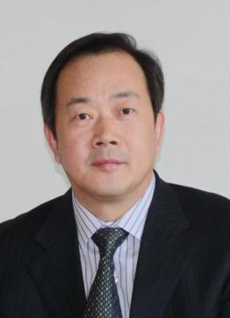
果德安 研究员
中国科学院上海药物研究所研究员，中药标准化技术国家工程实验室主任，1999年获得国家杰出青年基金。兼任国家药典天然药物专委会主任委员、美国药典东亚专家委员会主席和欧洲药典委员等职；任World J Trad Chin Med, Phytomedicines等18个国际杂志的主编、副主编或编委。主要从事中药分析与质量标准研究。以第一完成人获国家自然科学二等奖、国家科技进步二等奖；还获何梁何利科技进步奖、全国创新争先奖、美国植物药委员会Farnsworth卓越研究奖、美国生药学会Varo Tyler奖等奖项。发表SCI论文520余篇，被SCI引用14,000余次，H指数56。

Prof.Guo De-an
Chair professor of Shanghai Institute of Materia Medica and director of the National Engineering Laboratory for TCM Standardization Technologies.Received the National Outstanding Youth Fund in 1999.He also serves as the chairman of the National Pharmacopoeia Natural Medicines Committee, the chairman of the US Pharmacopoeia East Asia Expert Committee, and the European Pharmacopoeia; he is the editor-in-chief, deputy editor or editorial board member of 18 international journals such as World J Trad Chin Med, Phytomedicines.Mainly engaged in Chinese medicine analysis and quality standard research.As the first person to complete, he won the National Natural Science Second Prize and the National Science and Technology Progress Second Prize; he also won the He Liang Heli Science and Technology Progress Award, the National Innovation Award, the American Botanical Commission Farnsworth Research Excellence Award, the American Pharmacognosy Association Varo Tyler Award and other awards . Published more than 520 SCI papers, which have been cited by SCI more than 14,000 times, with an H index of 56.

赵中振 教授
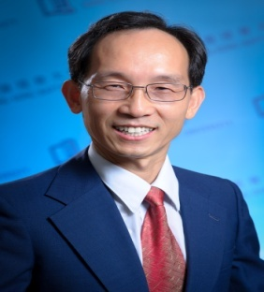
香港浸会大学中医药学院讲座教授。兼任香港中医中药发展委员会委员，香港中药标准科学委员会与国际顾问委员会委员，世界卫生组织西太区传统医药临时顾问，中国药典委员会委员等。长期致力于中药鉴定学、本草学研究，并积极参与并推动中医药教育及国际交流。在海内外学术期刊上发表原始论文160余篇。代表性著作有《当代药用植物典》（中、英文版）、《中药显微鉴别图鉴》（中、英文版）、《常用中药材鉴别图典》（中、日、英文版）、《读本草说中药》、《行天下探岐黄》（简、繁体版）。1990年获得国家科技进步二等奖，2014年获得香港特区政府颁授的荣誉勋章(MH)。为纪念李时珍诞辰500周年，他倡议发起本草文化工程。他主讲的20集《中振说本草》在互联网上热播，为推动中医药文化的普及发挥了巨大的作用。

Prof. Zhao Zhongzhen
Dr. ZHAO Zhongzhen, Chair Prof. and the associate dean of the School of Chinese Medicine, Hong Kong Baptist University, is currently a member of the Chinese Pharmacopeia Commission, the Hong Kong Chinese Medicine Development Committee, and the International Advisory Board of Hong Kong Standard of Chinese Materia Medica. He is also a temporary advisor of traditional medicines in the West Pacific Region of the WHO and USP Herbal Medicines Compendium–East Asia Expert Panel Member. Prof. Zhao has published over 180 academic papers and 40 books on Chinese Materia Medica, pharmacognosy, and herbal medicinal authentication. The Medal of Honour awarded by the Hong Kong SAR Government. July1, 2014

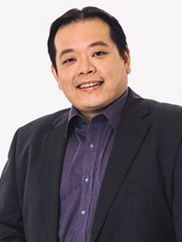
Justin Jang Hann CHU副教授

新加坡国立大学Yong Loo Lin医学院医学学术事务副院长，新加坡国立大学Yong Loo Lin医学院微生物与免疫学系副主任、教员，分子与细胞生物学研究所(IMCB)首席高级研究员，新加坡国立大学Yong Loo Lin医学院新加坡研究型高密度生物安全3级病毒实验室主任。Chu副教授致力于引起手足口病的人类肠道病毒以及登革热、寨卡病毒、日本乙型脑炎病毒和基孔肯雅病毒等蚊媒病毒的分子生物学研究。这些研究成果不断为已进入临床转化评估阶段的抗病毒策略（包括：抗病毒药物、疫苗、治疗抗体、分子抑制剂）和诊断方法的发展提供支持。该研究目前已获得8项专利以及众多的科学奖项。发表了90多篇国际同行评审的科学出版物、图书章节和100多篇会议论文，许多论文发表在Science Translational Medicine, Nature Communications, PNAS, PLoS Pathogens, Biomaterials, Journal of Biological Chemistry, Journal of Virology and Antiviral therapy等著名期刊上。Chu教授也是医学病毒学和抗病毒策略领域很多期刊的副主编和审稿人。

Associate Professor Justin Jang Hann CHU
A/P Chu is currently the Assistant Dean for Academic Affairs and a faculty member in the Department of Microbiology and Immunology, Yong Loo Lin School of Medicine, National University of Singapore. He is holding a Joint Senior Principal Investigator in the Institute of Molecular and Cell Biology (IMCB), A*STAR. A/P Chu is also the Director of the largest research based high containment Biosafety Level 3 Facility in Singapore which is located in the Yong Loo Lin School of Medicine, NUS. A/P Chu is actively engaged in the study of the molecular biology of human enteroviruses that cause HFMD as well as mosquito-borne viruses including Dengue, Zika, Japanese Encephalitis and Chikungunya. The outcome of these studies are helping to pave the roadmap towards the development of a number of antiviral strategies (antivirals, vaccines, therapeutics antibodies, molecular inhibitors) and diagnostics that are now undergoing clinical translational evaluation. Eight patents and numerous scientific awards have been received from his current research. A/P Chu has published over 90 international peer-reviewed scientific publications, book chapters and over 100 conference papers. A number of these scientific papers are published in prestigious journals including Science Translational Medicine, Nature Communications, PNAS, PLoS Pathogens, Biomaterials, Journal of Biological Chemistry, Journal of Virology and Antiviral therapy. A/P Chu is currently serving as the associate editor and reviewer for a number of peer-reviewed journals in the areas of medical virology and anti-viral strategies.

